INSTRUCTIONS FOR DISMANTLING, RE-ASSEMBLING AND SERVICING
3-SPEED MOTOR UNIT

REMOVAL  I. TURNTABLE  Remove wire circlip from centre of Turntable. Turntable should then be lifted right off spindle with a small to and fro rotary movement. | REPLACEMENT  I.  1. Check that Ball Thrust Cage and Washers are free from foreign matter and lubricated with a small quantity of light grease. Ball Race Cage must be replaced open side downwards with steel thrust washer immediately below and another immediately above it. Resilient washers of neoprene are fitted below and above the steel thrust washers, the upper neoprene washer having a larger centre hole and locating in the recessed end of turntable boss to which it should be fitted before replacing Turntable  2. 2. Check that the Fan (6) and Motor Pulley (4) are correctly located on the Motor Spindle in accordance with instructions given, SECTIONS IV and V.  3. Check that the Idler Wheel(29) also the rubber wheel which drives change mechanism are in their retracted positions clear of the turntable rim.  4. Replace Turntable on spigot, fit the retaining wire circlip and check that Turntable spins quite freely.
Important Note
Take great care to avoid depositing grease or oil on the Motor Pulley (4), the Idler Wheel (29), or the inside rim of the Turntable, as even a minute tracer will cause the drive to slip. As a precaution against this, it is advisable to wipe these parts with a clean petrol-moistened rag immediately prior to re-assembly. In case of Record Changers, also avoid depositing grease or oil on the sliding member in the top of the record spindle, as this may prevent it falling freely under its own weight, causing records to drop more than one at a time.
II. IDLER WHEEL (29)  1. Remove Screw (27) and Fibre Washer (28).  2. Withdraw Idler Wheel (29) upwards from its spindle. | 1. Reverse procedure given opposite, taking care that all washers are correctly in place.  2. Check that Idler Wheel spins freely and runs true within the limits specified in the tabulated information given in SECTION X1, (11) - (17) inclusive.
Important Notes
1. Most machines have one or two Fibre Washers (30) fitted under the Idler Wheel (29), but some have no washers in this position. When fitted, these Washers generally adhere to the boss of the Idler Wheel when it is withdrawn. Be sure to replace Washers exactly as found when dismantling. Do not confuse Washer (28)-small hole, with Washer (30)-large hole.
2. Do not over tighten Screw (27) as this may distort Fibre Washer (28), causing the Idler Wheel (29) to be stiff on its bearing.

III. MOTOR UNIT (as a whole)  I. Disconnect mains lead supplying motor.  2. Remove Turntable. (See Section 1).  3. Remove Switch Cover and slide the two spring contacts off the lugs which locate them in the Switch base, taking care not to distort the contacts.  4. Uncouple the speed control link by removing the Circlip (18).  5. Remove Idler Wheel (See Section II).  6. Detach Spring (36) from post in Idler Slide Arm (35), lift Idler Withdrawal Link (37) from post and swing clear.  7. Remove three screws (1), (3) and (33) which secure the motor frame to the base plate. NOTE-A shakeproof washer (2) is used under the head of the screw nearest the turntable centre, and must be replaced in that position | Reverse procedure given opposite, taking all precautions given in Sections II and I when replacing Idler Wheel and Turntable respectively. Check also that the Fan (6) and Motor Pulley (4) are correctly located on Motor Spindle, in accordance with instructions given in Sections IV and V.
IV. MOTOR PULLEY (4)  1. Hold Cooling Fan (6) stationary by inserting finger tip between the blades.  2. 2. Grip the Motor Pulley (4) with thumb and finger of the other hand, and turn it in an anti-clockwise direction, at the same time pulling it, gently upwards. The coupling spring (5), usually comes away with the Pulley, but in any case should be removed from the Fan Boss for purposes of re-assembly. | I.  1. Press Motor Pulley (4) into the Coupling Spring (5) with a left hand twisting movement until the end coil of the Spring sits firmly against the shoulder of the Pulley.  NOTE-The end of the Spring without the projecting tail should be next to the Pulley.  2. Hold Cooling Fan (6) stationary by inserting finger tip between blades.  3. Slide Pulley (with Spring attached) on to the Motor Spindle so that the open end of the Spring engages with the neck of the Fan Boss. Grip Pulley with thumb and finger, turn it in an anti-clockwise direction, at the same time pressing it gently downwards. When properly located the bottom of the Pulley should butt firmly against the top ofe Fan Boss.  4. Check that Motor spins freely and that Motor Pulley runs true within limits specified in the tabulated information given in SECTION XI, *8), (9) and (10).
Important Notes
1. Take care not to distort Fan Blades (see Section V)
2. Cooling fan (6) is a drive fit on Motor Spindle and is set so that the Motor Pulley will be at correct level when butting against it. Do not push Motor Pulley forcibly downwards when replacing it, as this may disturb location of the Fan on the Spindle (Refer to Section V for instruction on checking and setting level of Cooling Fan).
3. As a ready means of checking correct working level of the Motor Pulley (4) the Service Engineer should equip himself strip of metal 3½ “ long, 11/32” wide. This should be used by laying edge-wise on top of the Unit Plate, so as to bridge the aperture through which the Motor Pulley protrudes. The upper edge should just pass under the flange of the Motor Pulley.

V. COOLING FAN (6)  First remve Idler Wheel (29) and Motor Pulley (4) as described in Sections II and IV respectively. The Cooling Fan (6) may then be prised off the Motor Spindle, taking great care to avoid bending the Motor Spindle. For this purpose a pair of suitable bent levers should be used simultaneously on opposite sides, taking care to prise directly on the underside of the Fan Boss to avoid distorting the blades. | If necessary, pinch the split neck of the Fan Boss to make it a tight c fit on the Motor Spindle. Do not close in too much as undue force may then be necessary to push it on to the Motor Spindle. If over-tight a length of 3/16” 'diameter rod with a tapered end, should be driven the Boss before attempting to push it on to the Motor Spindle.  To push the Fan into position on the Motor Spindle, it is convenient use a short length of tube 9/32” diameter bore. This should be gently tapped down until the top of the split neck of the Fan Boss is 7/16” above the flat face of the motor frame. If set too low, prise upwards as described opposite.  Finally, check that all six fan blades have adequate clearance, setting any blades that are out of line. The lower edge of each blade should be parallel to the face of the motor frame with a gap of about 1/16”.
VI. IDLER SWIVEL ARM (31)  I. Remove Idler Wheel (29) as described in Section II.  2. loosen Set Screw (32) two or three turns.  3. Withdraw Spindle (34) upwards, thus enabling the Idler Swivel Arm (31) to be withdrawn sideways from between the forks of the Idler Slide Arm (35). | Reverse procedure given opposite. Take care to replace Spindle so that the recessed portion engages with the Set Screw (32). The Spindle (34) should be set so that each of its ends is slightly proud of the out faces of the forks of the Idler Slide Arm (35). Tighten Set Screw securely and check that the Swivel Arm (31) swings quite freely on Slide Arm (35).  NOTE-The lug" X " of the Swivel Arm (31) must be, assembled so a engage with the recess" X " of the Slide Arm (35).
VII. IDLER SLIDE, ARM (35)  NOTE-Idler Swivel Arm (31) may be left attached to the Slide Arm (35) during, this operation, or alternatively it may be separately removed, as described in Section VI.  I. Remove Idler Wheel (29). (See Section II).  2. Detach Spring (36) from Post in Idler Slide Arm (35), lift Idler Withdrawal Link (37) from post and swing clear.  3. loosen Set Screw (8) two or three turns.  4. Withdraw Spindle (II) upwards, thus enabling the Slide Arm (35) to be detached.  NOTE-Withdrawal of the Spindle (II) also releases the Thrust Collar (13). | Reverse procedure given opposite. Take care to replace Spindle (11) so that the recessed portion is engaged by the Set Screw (8).  Thread the Thrust Collar (13) on to the lower end of the Spindle ( with its bevelled end downwards in contact with the upper face of 3-speed Control Cam (19). The Spindle (II) should then be set so its upper end projects 11/32” above the flat face of the motor frame, and Set Screw (8) tightened securely

VIII. 3-SPEED CONTROL CAM (19)  IDLER WITHDRAWAL LEVER (24) ETC.  1. Remove Circlip (18) and swing Control Link clear.  2. Detach Spring (23). .  3. Remove Self Locking Nut (22). All items numbered 13 to 26 inclusive can then be detached. | I. Assemble items 24, 25, 26 together, and assemble to Motor Frame taking care to locate the limb “A” of the Idler Withdrawal Lever (24) behind the peg  " “A” projecting from the bottom member the Idler Slide Arm (35).  2. Slide Thrust Collar (13) on to lower end of spindle (II) with , bevelled end downwards.  3. Slide Spring (14) on to the plain portion of the Spindle with threaded end projecting downwards from the motor frame.
GENERAL INSTRUCTIONS FOR MAINTENANCE OF MOTOR AND TURNTABLE DRIVE

IX.
No lubrication of the motor is normally required as it is fitted with self-oiling bearings. The only maintenance necessary consists in occasional removal of turntable to clean its inner rim and the driving surfaces of the Motor Pulley (4) and Idler Wheel (29), by wiping with; a clean petrol-moistened rag. The thrust washers and ball race fitted underneath the turntable bearing should also be examined, and if necessary, washed clean with petrol and relubricated with a small amount of soft grease. When carrying out these operations, carefully observe all instructions given in Section I concerning removal and replacement of the Turntable.

Should any defects not covered by these service instructions develop in the Motor, or should lubrication of the motor bearings appear to be necessary at a very long period of service, it is recommended that the complete motor unit should be returned to the manufacturers for overhaul or replacement. Dismantling of the main motor assembly, beyond the stage depicted in Item 7 of the Drawing, is not recommended as it is difficult to re-assemble the Motore satisfactorily: without special equipment, and noisy running and uneven speed may result.

ADJUSTMENTS NECESSARY IN THE EVENT OF CHANGES IN VOLTAGE AND/OR PERIODICITY OF SUPPLY

X.
Each Motor carries an engraved plate giving details of the periodicity and voltage of the supply with which it may be used.

Change of Periodicity
A replacement Motor Unit and Motor Pulley to suit the new periodicity must be fitted.

Change of Voltage
In the case of single voltage motors, a replacement Motor Unit must be fitted if the new voltage lies outside the range indicated on the Motor Plate. In the case of dual voltage motors, there are two types of adjustment which may be encountered, and these should be set to the appropriate voltage range indicated in the illustrations below.

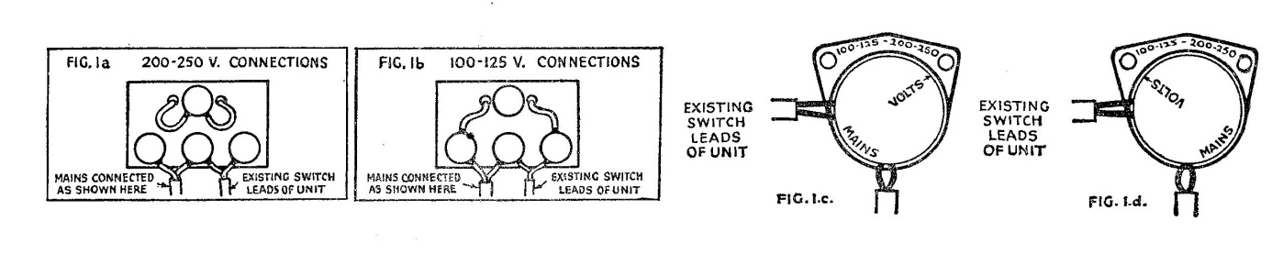

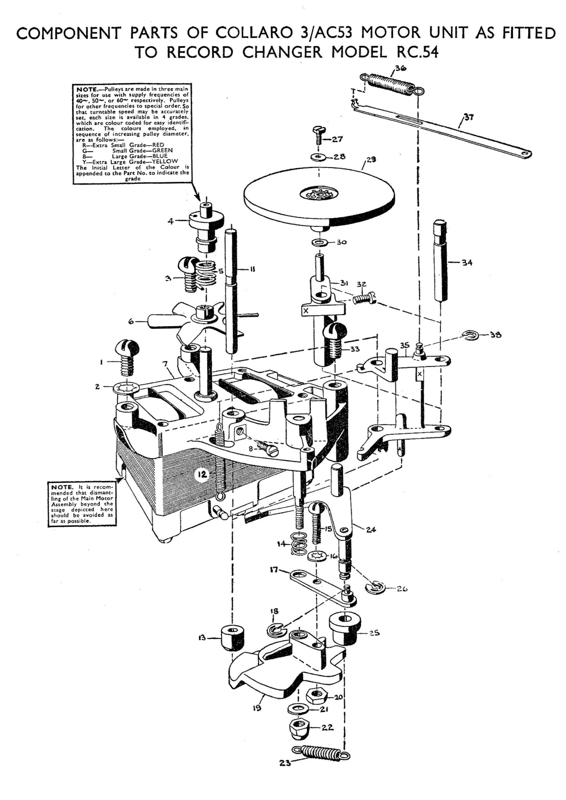

DIAGNOSIS OF FAULTS AND SUGGESTED REMEDIES

XI.
GENERAL INFORMATION

Apart from faults arising directly from the Pickup. the satisfactory reproduction of gramophone records is basically dependent upon the maintenance of correct and uniform speed. In order to achieve this, it is absolutely necessary to maintain correct and uniform speed of the Turntable itself. But it is important to remember that uneven speed of the record as it passes the stylus may arise from other causes such as:-
1. Enlarged, centre holes in records resulting in eccentric rotation, causing excessive sideways swing of the Pickup Head.
2. Warping of records causing excessive up and down movement of the Pickup Head. .
3. High spots on records or distortion, resulting in failure of the records to drive each other when used mare than one at a time an Record Changers. Before preceding to investigate any faults on the basis of the information which follows, it is essential to eliminate the above three possible sources. For this purpose the Service Engineer is recommended to select and carefully preserve a set .of test records In which he knows these defects to be wholly absent. It is also important to make sure that the drive to the Turntable is not slipping, due to the presence .of grease or oil an the driving surfaces of the Pulleys or the inside rim of the Turntable. (See .instructions for cleaning in Section IX).
It will be of great assistance to the Service Engineer when tracing the source of “WoW” to remember that defects in the Turntable itself will, in general cause “WoW” to occur regularly at Turntable speed, whilst defects in the Idler Wheel will generally cause it to occur at approximately four times Turntable speed. These are not invariable rules; for example, the Turntable bearing may have tight spots in two diametrically opposite positions, thus causing “Wow” at twice Turntable speed.

CONDITIONS ESSENTIAL FOR SATISFACTORY OPERATION OF MOTOR UNIT

The information given in the following Table is based on the tolerances and precautions actually observed in manufacture and assembly. While the Service Engineer may not always have means at his disposal for checking all the tolerances quoted, the information will, nevertheless, give a useful indication of the degree of accuracy considered necessary to ensure satisfactory reproduction of records, and s0 help him in the diagnosis of any faults encountered.

Condition | Defect Produced by Non-compliance With Condition | Probable Cause of Defect
MOTOR  1. Motor must spin freely.  2. Motor must run quietly. | Slow running.  Uneven Speed  Noisy running.  Background Rumble. | Bearings out of alignment. (Tap Motor lightly an all sides whilst running to line up bearings).  Rotor net central in tunnel of Stator. (Te centralize (I) loosen 6 Clamp Bolts (heads on underside of Mater Frame); (II) insert 2 shims 1" wide x .010" thick between Stator and Rotor; (III) tighten 6 Clamp Baits; (IV) withdraw shims.).
TURNTABLE  3. Inside of rim must run concentric within .006,", and be free from all irregularities.  4. Face (near rim) must run true within .010". (Test with truly flat disc 10" dia. en Turntable.).  5. Turntable bearing, with Circlip in place, must have small amount .of end play (.015" max.)  6.  6.  6.turntable must spin freely without any trace of a tight spat (a tight spot is indicated by a tendency to come to rest predominantly in one position - to test mark edge .of Turntable with chalk .or gummed paper.)  7. 7. Bearing must run silently and smartly. | Wow.  Wow.  Slow running.  Noisy running  Wow.  Background Rumble  Wow.  Noisy running.  Rumble | (I) Distorted Turntable. (II) Foreign matter adhering to inside of rim.  (I) Distorted Turntable. (II) Displacement of Rubber Mat.  Extra steel or neoprene washers, or incorrect washers, fitted under turntable bearing. (If from this cause, fault will disappear if wire circlip is removed from center of Turntable.)  (I) Dirty or dry bearing. (II) Damaged steel thrust washer. (III) Damaged ball in thrust race. (IV) Ball binding in Thrust Cage. (V) Damaged ball cage, contacting thrust washer or binding on spigot. (VI) No end play in bearing (See Condition 5).  (I) Dirty or dry bearing. (II) Damaged steel thrust washer. (III) Damaged ball in thrust race. (IV) Ball binding in thrust cage. (V) Omission of neoprene cushion washer. (VI) Damaged ball cage, contacting thrust washer or binding on spigot. (VII) No end play in bearing (See condition 5).
MOTOR PULLEY (4)  8. Driving surfaces must run concentric within .002" and be free from flats or other irregularities.  9. Must be close sliding fit on Motor Spindle without perceptible play.  10  10. Must be set at correct working level, (Level is controlled by position of Fan on Motor Spindle - See SECTION V) and must engage Idler Wheel correctly (See Condition 16) | Flutter.  Cross Modulation.  Noisy running.  (Probably in the form of intermittent light rattling). | (I) Bent motor spindle. (II) Enlarged bare in pulley. (III) Burr an motor spindle.  (I) Enlarged bore in pulley. (II) Undersize Motar Spindle.  I) Idler Wheel overlapping flange of Motor Pulley at 78 r.p.m. (II) Face of Idler Wheel contacting flange of Motor Pulley on either 33 r.p.m. or 45 r.p.m.
IDLER WHEEL (29)  11. Rim must run concentric within .002" and be free from flats or other irregularities.  12. Face (near rim) must run true within .010".  13. Wheel must spin freely without trace of tight spats (with retaining washer and screw in place.).  14. Bearing must have end play (.005" max.) (with retaining washer and screw in place).  15. Plane of Wheel must be square to Motor Spindle.  16.  16. Wheel must be set at correct working level (i.e., centrally disposed relative to largest. flange of Motor Pulley when .operating on 78 r.p.m.).  17. Wheel must clear top of spindle (11) when operating on 45 r.p.m. | Wow.  Noisy running.  (Probably in the form of regular low thumping).  Wow (caused by rim overriding 78 r.p.m. flange of Motor Pulley, or intermittently touching face of 78 r.p.m. flange when operating on 33 1/3 or 45 r.p.m  Wow.  Slow running.  Wow.  Slow running.  Slow running.  (Accompanied by scurfing of the rubber rim).  Slow running.  Wow.  Failure of drive to engage 45 r.p.m.  No drive or uneven speed on 45 r.p.m. | (I) Distorted Idler Wheel. (II) Rubber damaged at rim. (III) Boss loosened in Idler Wheel. (IV) Foreign matter adhering to rim.  (I) Distorted Idler Wheel  (II) Boss loosened in Idler Wheel.  I) Bush tight an Spindle. (II) Dry bearing. (III) No end play in bearing (See Conditions 14).  I) Washer omitted (above or below bearing) causing excessive end play permitting rim of wheel to override flange of Motor Pulley. (See Condition 10.). (II) Extra washer or incorrect washer fitted, causing lack .of end play and possibly tightness.  Distorted Idler Swivel Arm (31).  (I) Rim of Idler Wheel overriding 78 r.p.m. flange of Motor Pulley. (II) Face of Idler Wheel touching face of 78r.p.m. flange of Motor Pulley when operating on 33 r.p.m. or 45 r.p.m. (III) Idler Swivel Arm (31) fouling Motor Frame. Correct above faults by adjusting Nut (22) after first checking that Motor Pulley is at correct level. (See Notes at end .of SECTION VI).  (I) Incorrect setting of Spindle (11). (See SECTION VII). (II) Incorrect adjustment of Nut (22). (See 16 above).

XII. PICK-UP SETTING DOWN POSITION

If positions are erratic, check first of all that the nut shown at D (Fig. 2) is securely tightened.

The position at which the stylus alights on the record may be adjusted, if necessary, by means of the two screws A and B (Fig. 2). To bring position further in, loosen screw A and tighten screw B the same amount. To bring position further out, loosen screw B and tighten screw A the same amount.

NOTE.-This adjustments is very sensitive; turn the screws only a small fraction of a turn at a time until the desired adjustment is obtained, and finally check that position is correct after both screws have been firmly tightened. AVOID EXCESSIVE FORCE when tightening these screws.

The machine gives automatic positioning for 7", 10" and 12" records and the above adjustment affects all positions equally. The design of the mechanism ensures that when the 7" setting down position is correctly adjusted the 10" and 12 " will be correct also in accordance with the following table based on the standards laid down by the principle record manufacturers

STANDARD SETTING-DOWN Measured from Measured From POSITIONS turntable side of record
centre spindle
for 7" Records ... ... ... 3.11/32" 3.13/64"
for 10" Records … ... ... 4.13/16" 4.43/64"
for 12" Records ... ... ... 5.13/16" 5.43/64"

All machines are adjusted in accordance with the above at the factory.

XIII. PICK-UP HEIGHT ADJUSTMENT

The height to which the pick-up arm is lifted during the change cycle is controlled by a simple self-locking adjustment shown at C (Fig. 2).
To make adjustment, if necessary, switch off the mains supply during the change cycle at the point where the pick-up arm has just swung outwards over its rest. The spindle C may then be screwed up or down as required by inserting any suitable pin into the transverse hole drilled near its projecting rounded end. Correct adjustment is when the pick-up arm clears the top of its rest by ⅛” approximately. Finally switch on mains supply again.

If machine does not start up and complete the change cycle when mains supply is re-connected, turn the control knob fully to the "START" position and hold there for a few moments before gently releasing.

XIV. RECORD DROPPING

Adjustment of the mechanism should not normally be necessary unless the machine has been partially dismantled to make replacements.

To adjust or check adjustment
(i) Remove all records and disconnect Mains Supply.
(ii) Loosen set bolt (38) two or three turns.
(iii) Operate start control.
(iv) Turn large Gear Wheel (39) in direction indicated by arrow in Fig. 3 until Record Dropping Lever (40) is moved to its extreme position. The Roller (41) will then be behinds and covered by the Operating Bar (42).
(v) Tighten set bolt (38) secuf1ely.
(vi) Reconnect Mains supply and test with full load of 12" records.

The Record Spindle, Dropping Mechanism, and Turntable Spigot Bearing Housing are built as a pre-adjusted unit. Under no circumstances should the Nut (43) or the Stop (44) be disturbed from their original setting. If damage has occurred or the adjustment has been disturbed; it is recommended that this unit should be replaced as a whole.

To remove ,Spindle Unit from machine:
(i) Remove Circlip (45) and Auto-trip Striker Arm (46).
(ii) Withdraw Split Pin (47)
(iii) Disengage Motor Switch lead from tab.
(iv) Remove Turntable (see Section I ).
(v) Remove 3 screws (68).
(vi) Disengage slot in Record Dropping Slide (48) from peg in Record Dropping Lever (40) after which spindle unit may be withdrawn.

To assemble replacement unit to machine:

Reverse above procedure taking care that the various parts are arranged exactly as shown in Fig. 3. When replacing Auto-trip Striker Arm (46) note that the rubber roller must face upwards towards the underside of the unit plate. After assembly is complete, adjust Record Dropping Roller (41) as indicated at beginning of this Section.
NOTES;-If records fail to drop. Worn or chipped centre holes can be the cause, and the use of records damaged in this way should be avoided. If failure occurs when using undamaged records, check adjustment of record dropping mechanism as indicated at the beginning of this Section

If more than one record drops at a time. Worn or chipped centre Holes may also be the cause. Also make sure that the small sliding member housed in the top of the spindle drops perfectly freely under its own weight. If it does not do so, it is probable that some foreign matter has become lodged between the slide and side of the groove in which it works, and this may best be dislodged by means of a thin razor blade. Grease or oil on the slide may also be the cause of its failure to drop freely, and consequently, great care should be exercised if the turntable is removed to avoid depositing on the slide any grease or oil from the turntable bearing. Petrol or other solvent applied with a small brush should be used to clean the parts if this cause of failure is suspected.

XV. SWITCHING ON

Normally the "START" control should be turned gently to the left until the turntable starts to rotate when it may be released. Stalling of the machine is unlikely to occur unless the mains supply is interrupted or disconnected at certain critical points in the change cycle. In all cases normal working may be restored by operating the "START" control to the extreme of its movement, and holding there for a few moments before gently releasing.

Failure to start may be caused by bent or damaged switch contacts. These may be inspected under working conditions by removal of the switch cover, taking care to avoid touching the contacts unless mains supply has first been disconnected.

XVI. AUTOMATIC TRIP

This is of the "Velocity Trip" variety and is designed to be extremely light and sensitive in operation. No adjustment is provided, and the only likely cause of failure is if the curved end of the Feed Lever (49) has been accidentally bent upwards or downwards so that the end of the Striker Arm (46) cannot work freely in the aperture in the side of the Diecast Housing carrying the turntable bearing, etc. Both the Feed Lever (49) and the Striker Arm (46) must be absolutely free on their respective pivots, and it is also worthy of note that the long Pin (50) must always lie within the forked end of the Feed Lever (51) as shown in Fig. 3.

XVII. STOP CONTROL

This movement should be operated firmly to its full extent to the right and released gently. Letting the knob fly back out of the fingers may in extreme cases cause failure of the machine to switch off, and another record may be played as if the "REJECT" control had been used.

XVIII. AUTOMATIC STOP

Any failures of the Automatic Stop (i.e., the automatic switching off of the machine after playing the last record) will be best diagnosed from the following description of the various functions performed by the mechanism..

The automatic stop is brought into operation after the last record has been played by reason of the Record Balancing Arm (69) having dropped to its fullest extent. This depresses the Auto Stop Lever (52) which in turn allows the Auto Stop Catch Plate (53) to fall and retain the Pick-up Return Lever (54) in the position shown in Fig. 3. The Pick-up Arm is thus not returned inwards over the records, but subsides on to its rest at the end of the change cycle. At the same time the Pick-up Return Lever (54) through the medium of the Switch-off Plate (55) restrains the Switch-off Link (56) in the position shown in Fig. 3. against the pull of the Spring (57). The turned up end of the Switch-off Link is thus held in the path of the Peg (58) and at the end of the cycle, the notch in the Switch Pawl (59) is disengaged from the Peg (60), and the Spring (61) holds the motor switch open and simultaneously retracts the Rubber Idler Wheel (70) through the medium of the Lever (62) and the Link (71).

On switching on again, the Control Lever (63) disengages the turned-up end of the Switch-off Link (56) from the Peg (58) thus allowing the notch in the Switch Pawl (59) to engage with the Peg (60) so holding the motor switch closed and at the same time holding the Rubber Idler Wheel (70) in contact between the Motor Pulley and the Turntable Rim. If, at the same time, one or more records have been loaded on to the machine, the Auto-Stop Lever (52) will lift under the Influence of its spring (72) as soon as the Pick-up Return Lever (54) is moved momentarily out of the nitch in the Auto-Stop Catch Plate (53) during the change cycle. This removes all restraint on the various parts of the mechanism, and the cycle is completed in the normal way. If, however, no records have been loaded on to the machine and the Record Balancing Arm (69) remains dropped to its fullest extent the Pick-up Lever (54) will not be released, and the Pick-up Arm will again subside on its rest and the machine will switch-off at the completion of the cycle.

The purpose of the small Pawl (64) attached to the Auto-Stop Catch Plate (53) is to prevent the Pick-up Return Lever (54) being retrained as the last record falls, which would cause the machine to switch off without playing the last record. This Pawl (64) thus delays the restraint of the Pick-up Return Lever until the next cycle, i.e., after the playing of the last record is completed.

For satisfactory working it is essential that all parts mentioned above should work absolutely freely, and that the Spring (72) should positively actuate the Auto-Stop Lever (52) lifting the Auto-Stop Catch Plate (53) with it. At the same time the Spring (72) must not be so strong as to prevent the weight of the Record Balancing Arm fully depressing the Auto-Stop Lever (52).

XIX. CONTINUOUS OPERATION OF CHANGE CYCLE

If the change mechanism operates continuously without allowing each record to play to the end the cause can be:
(1) Weakening or displacement of Spring (65).
(2) Drive Withdrawal Pawl (66) being stiff on its pivot (73).
(3) Auto-Trip Lever (74) being stiff on its pivot.

All the above causes may have the effect of preventing the Drive Withdrawal Pawl being properly picked up by the Pin (67) in the Operating Gear (39).

